Практическая работа №5
Тема: «Построение Машины вывода для Экспертной
Системы реляционного типа»

Цель: разработать интерактивное картографическое приложение на платформе Windows Forms с использованием картографического компонента, обеспечивающее отображение географических объектов, а также возможность взаимодействия с картой для повышения навыков создания графических интерфейсов и работы с географическими данными в рамках реляционной системы.

Ход работы
- Создаем дизайн для нашей программы (на самом деле нет)
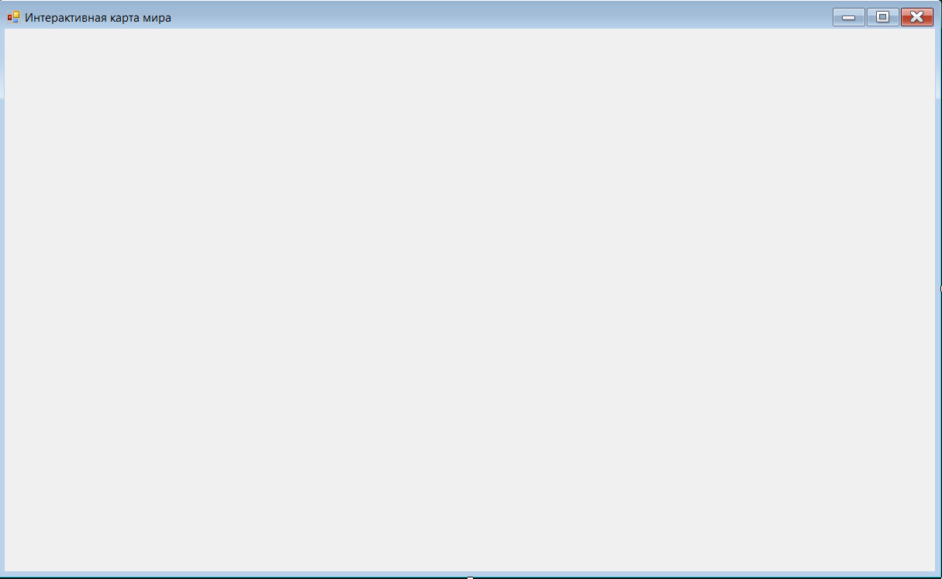
- Пишем код для нашей программы
using GMap.NET;
using GMap.NET.MapProviders;
using GMap.NET.WindowsForms;
using GMap.NET.WindowsForms.Markers;
using Newtonsoft.Json.Linq;
using System;
using System.Collections.Generic;
using System.Drawing;
using System.Net.Http;
using System.Threading.Tasks;
using System.Windows.Forms;

namespace WorldMapCountryInfo
{
public partial class Form1 : Form
{
private GMapControl gMapControl;
private Panel infoPanel;
private PictureBox flagPictureBox;
private Label countryNameLabel;
private Label currencyLabel;
private Label populationLabel;
private GMapOverlay markersOverlay;
private HttpClient httpClient;

private readonly (string name, double lat, double lng)[] countries = new[]
{
("Россия", 61.5240, 105.3188),
("США", 37.0902, -95.7129),
("Китай", 35.8617, 104.1954),
("Германия", 51.1657, 10.4515),
("Франция", 46.2276, 2.2137),
("Великобритания", 55.3781, -3.4360),
("Япония", 36.2048, 138.2529),
("Индия", 20.5937, 78.9629),
("Бразилия", -14.2350, -51.9253),
("Канада", 56.1304, -106.3468)
};

public Form1()
{
InitializeComponent();

var handler = new HttpClientHandler
{
AutomaticDecompression = System.Net.DecompressionMethods.GZip | System.Net.DecompressionMethods.Deflate
};

httpClient = new HttpClient(handler)
{
Timeout = TimeSpan.FromSeconds(15)
};

httpClient.DefaultRequestHeaders.Add("User-Agent", "WorldMapCountryInfo/1.0");
httpClient.DefaultRequestHeaders.Add("Accept", "application/json");

InitializeMap();
InitializeInfoPanel();
}

private void InitializeMap()
{
gMapControl = new GMapControl
{
Dock = DockStyle.Fill,
MapProvider = GMapProviders.GoogleMap,
Position = new PointLatLng(20, 0),
MinZoom = 2,
MaxZoom = 18,
Zoom = 3,
ShowCenter = false,
DragButton = MouseButtons.Left
};

gMapControl.OnMarkerClick += GMapControl_OnMarkerClick;
gMapControl.MouseClick += GMapControl_MouseClick;

markersOverlay = new GMapOverlay("markers");
gMapControl.Overlays.Add(markersOverlay);

AddCountryMarkers();

this.Controls.Add(gMapControl);
}

private void AddCountryMarkers()
{
foreach (var country in countries)
{
var marker = new GMarkerGoogle(
new PointLatLng(country.lat, country.lng),
GMarkerGoogleType.blue_dot);

marker.ToolTipText = country.name;
marker.ToolTipMode = MarkerTooltipMode.OnMouseOver;
marker.Tag = country.name;
markersOverlay.Markers.Add(marker);
}
}

private void InitializeInfoPanel()
{
infoPanel = new Panel
{
Dock = DockStyle.Right,
Width = 300,
BackColor = Color.White,
BorderStyle = BorderStyle.FixedSingle,
Padding = new Padding(10)
};

var titleLabel = new Label
{
Text = "Информация о стране",
Font = new Font("Arial", 14, FontStyle.Bold),
ForeColor = Color.DarkBlue,
Dock = DockStyle.Top,
Height = 40,
TextAlign = ContentAlignment.MiddleCenter
};

flagPictureBox = new PictureBox
{
Size = new Size(200, 120),
SizeMode = PictureBoxSizeMode.Zoom,
BorderStyle = BorderStyle.FixedSingle,
BackColor = Color.LightGray,
Location = new Point(50, 50),
Parent = infoPanel
};

countryNameLabel = new Label
{
Text = "Выберите страну на карте",
Font = new Font("Arial", 12, FontStyle.Bold),
ForeColor = Color.Black,
Location = new Point(10, 180),
Size = new Size(280, 30),
TextAlign = ContentAlignment.MiddleCenter,
Parent = infoPanel
};

currencyLabel = new Label
{
Text = "Валюта: -",
Font = new Font("Arial", 10),
ForeColor = Color.Black,
Location = new Point(10, 220),
Size = new Size(280, 25),
Parent = infoPanel
};

populationLabel = new Label
{
Text = "Население: -",
Font = new Font("Arial", 10),
ForeColor = Color.Black,
Location = new Point(10, 250),
Size = new Size(280, 25),
Parent = infoPanel
};

infoPanel.Controls.Add(titleLabel);
this.Controls.Add(infoPanel);
}

private async void GMapControl_OnMarkerClick(GMapMarker item, MouseEventArgs e)
{
if (item.Tag != null && item.Tag is string countryName)
{
await LoadCountryInfo(countryName);
}
}

private async void GMapControl_MouseClick(object sender, MouseEventArgs e)
{
if (e.Button == MouseButtons.Right)
{
var point = gMapControl.FromLocalToLatLng(e.X, e.Y);
await GetCountryByCoordinates(point.Lat, point.Lng);
}
}

private async Task GetCountryByCoordinates(double lat, double lng)
{
try
{
string url = $"https://api.bigdatacloud.net/data/reverse-geocode-client?latitude={lat}&longitude={lng}&localityLanguage=ru";

var response = await httpClient.GetStringAsync(url);
var json = JObject.Parse(response);

var country = json["countryName"]?.ToString() ??
json["country"]?.ToString() ??
json["address"]?["country"]?.ToString();

if (!string.IsNullOrEmpty(country))
{
await LoadCountryInfo(country);
}
else
{

await TryAlternativeGeocoding(lat, lng);
}
}
catch (Exception ex)
{
MessageBox.Show($"Ошибка при получении данных по координатам: {ex.Message}", "Ошибка",
MessageBoxButtons.OK, MessageBoxIcon.Error);
}
}

private async Task TryAlternativeGeocoding(double lat, double lng)
{
try
{
string url = $"http://api.geonames.org/countryCode?lat={lat}&lng={lng}&username=demo";

var response = await httpClient.GetStringAsync(url);

if (!string.IsNullOrWhiteSpace(response))
{
string countryCode = response.Trim();
await GetCountryNameByCode(countryCode);
}
}
catch
{
MessageBox.Show("Не удалось определить страну по координатам", "Информация",
MessageBoxButtons.OK, MessageBoxIcon.Information);
}
}

private async Task GetCountryNameByCode(string countryCode)
{
try
{
string url = $"https://restcountries.com/v3.1/alpha/{countryCode}";
var response = await httpClient.GetStringAsync(url);
var jsonArray = JArray.Parse(response);

if (jsonArray.Count > 0)
{
var countryData = jsonArray[0];
var countryName = countryData["name"]?["common"]?.ToString();

if (!string.IsNullOrEmpty(countryName))
{
await LoadCountryInfo(countryName);
return;
}
}
}
catch
{

}

MessageBox.Show("Не удалось определить страну по координатам", "Информация",
MessageBoxButtons.OK, MessageBoxIcon.Information);
}

private async Task LoadCountryInfo(string countryName)
{
try
{
countryNameLabel.Text = countryName;
currencyLabel.Text = "Загрузка...";
populationLabel.Text = "Загрузка...";
flagPictureBox.Image = null;

string countryData = await TryGetCountryData(countryName);

if (!string.IsNullOrEmpty(countryData))
{
ParseAndDisplayCountryInfo(countryData, countryName);
}
else
{
ShowErrorInfo(countryName);
}
}
catch (Exception ex)
{
MessageBox.Show($"Ошибка при загрузке данных: {ex.Message}", "Ошибка",
MessageBoxButtons.OK, MessageBoxIcon.Error);

ShowErrorInfo(countryName);
}
}

private async Task<string> TryGetCountryData(string countryName)
{
var apiUrls = new[]
{
$"https://restcountries.com/v3.1/name/{Uri.EscapeDataString(countryName)}?fullText=true",

$"https://restcountries.com/v2/name/{Uri.EscapeDataString(countryName)}",

$"https://restcountries.com/v3.1/name/{Uri.EscapeDataString(countryName)}",

$"https://restcountries.com/v3.1/translation/{Uri.EscapeDataString(countryName)}"
};

foreach (var apiUrl in apiUrls)
{
try
{
var response = await httpClient.GetAsync(apiUrl);

if (response.IsSuccessStatusCode)
{
return await response.Content.ReadAsStringAsync();
}

if (response.StatusCode == System.Net.HttpStatusCode.NotFound)
{
continue;
}

response.EnsureSuccessStatusCode();
}
catch
{
continue;
}
}

return null;
}

private void ParseAndDisplayCountryInfo(string jsonData, string originalName)
{
try
{
var jsonArray = JArray.Parse(jsonData);

if (jsonArray.Count > 0)
{
var countryData = jsonArray[0];

string displayName = originalName;

var translations = countryData["translations"];
if (translations != null && translations["rus"] != null)
{
displayName = translations["rus"]["common"]?.ToString() ?? originalName;
}
else if (countryData["name"] != null)
{
var nameObj = countryData["name"];
displayName = nameObj["common"]?.ToString() ??
nameObj["official"]?.ToString() ?? originalName;
}

string currency = "Неизвестно";
var currencies = countryData["currencies"];
if (currencies != null && currencies.HasValues)
{
var firstCurrency = (currencies as JObject)?.First;
if (firstCurrency != null)
{
currency = firstCurrency.First?["name"]?.ToString() ??
firstCurrency.First?["symbol"]?.ToString() ?? "Неизвестно";
}
}

long population = 0;
if (countryData["population"] != null)
{
population = countryData["population"].Value<long>();
}

string capital = countryData["capital"]?.First?.ToString() ?? "Неизвестно";

string region = countryData["region"]?.ToString() ?? "Неизвестно";

string flagUrl = countryData["flags"]?["png"]?.ToString() ??
countryData["flag"]?.ToString();
countryNameLabel.Text = displayName;
currencyLabel.Text = $"Валюта: {currency}";
populationLabel.Text = $"Население: {FormatPopulation(population)} чел.";

if (!string.IsNullOrEmpty(flagUrl))
{
_ = LoadFlagImage(flagUrl);
}
else
{
flagPictureBox.Image = null;
}

return;
}
}
catch
{
}

ShowBasicInfo(originalName);
}

private void ShowBasicInfo(string countryName)
{
var basicInfo = new Dictionary<string, (string currency, long population, string flagCode)>
{
{"Россия", ("Российский рубль (RUB)", 146150789, "ru")},
{"США", ("Доллар США (USD)", 331002651, "us")},
{"Китай", ("Китайский юань (CNY)", 1439323776, "cn")},
{"Германия", ("Евро (EUR)", 83783942, "de")},
{"Франция", ("Евро (EUR)", 65273511, "fr")},
{"Великобритания", ("Фунт стерлингов (GBP)", 67886011, "gb")},
{"Япония", ("Японская иена (JPY)", 126476461, "jp")},
{"Индия", ("Индийская рупия (INR)", 1380004385, "in")},
{"Бразилия", ("Бразильский реал (BRL)", 212559417, "br")},
{"Канада", ("Канадский доллар (CAD)", 37742154, "ca")}
};

if (basicInfo.TryGetValue(countryName, out var info))
{
countryNameLabel.Text = countryName;
currencyLabel.Text = $"Валюта: {info.currency}";
populationLabel.Text = $"Население: {FormatPopulation(info.population)} чел.";

string flagUrl = $"https://flagcdn.com/w320/{info.flagCode}.png";
_ = LoadFlagImage(flagUrl);
}
else
{
ShowErrorInfo(countryName);
}
}

private void ShowErrorInfo(string countryName)
{
countryNameLabel.Text = countryName;
currencyLabel.Text = "Данные о валюте недоступны";
populationLabel.Text = "Данные о населении недоступны";
flagPictureBox.Image = null;

MessageBox.Show($"Не удалось загрузить подробную информацию о {countryName}.\nПроверьте подключение к интернету.",
"Информация", MessageBoxButtons.OK, MessageBoxIcon.Information);
}

private async Task LoadFlagImage(string url)
{
try
{
using (var stream = await httpClient.GetStreamAsync(url))
{
flagPictureBox.Image = Image.FromStream(stream);
}
}
catch
{
flagPictureBox.Image = null;
}
}

private string FormatPopulation(long population)
{
if (population >= 1000000000)
return $"{(population / 1000000000.0):F1} млрд";
else if (population >= 1000000)
return $"{(population / 1000000.0):F1} млн";
else if (population >= 1000)
return $"{(population / 1000.0):F1} тыс";
else
return population.ToString();
}

protected override void OnFormClosing(FormClosingEventArgs e)
{
httpClient?.Dispose();
base.OnFormClosing(e);
}
}
}
- Тестируем наше приложение
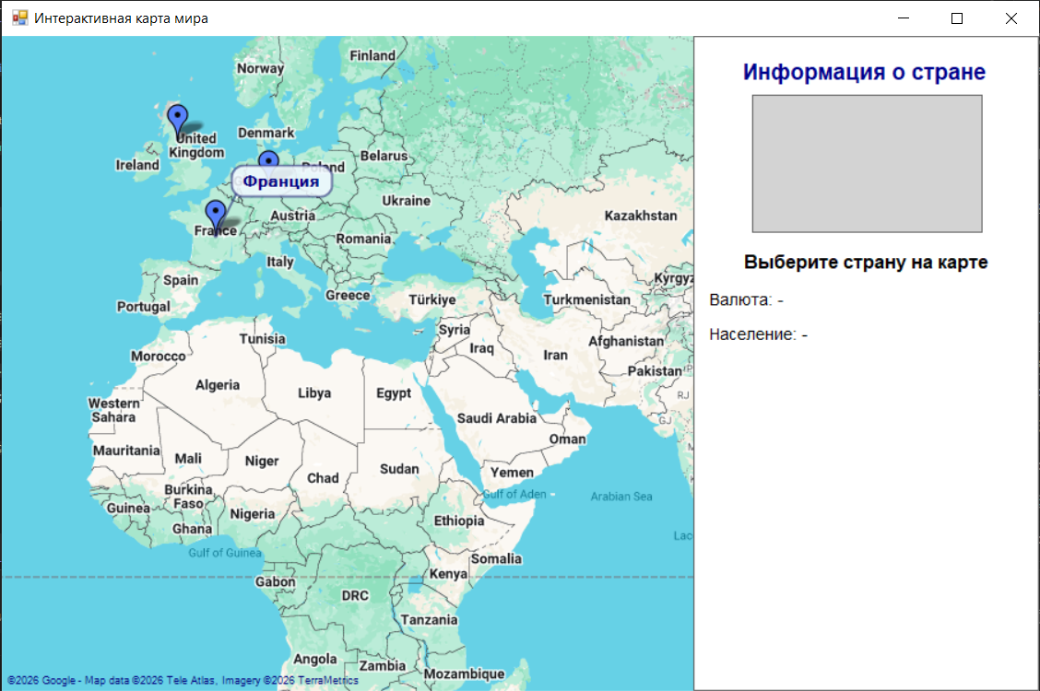
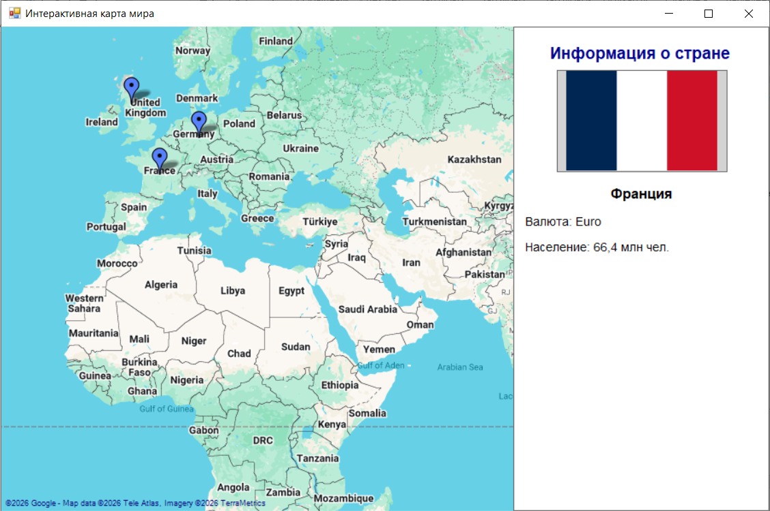
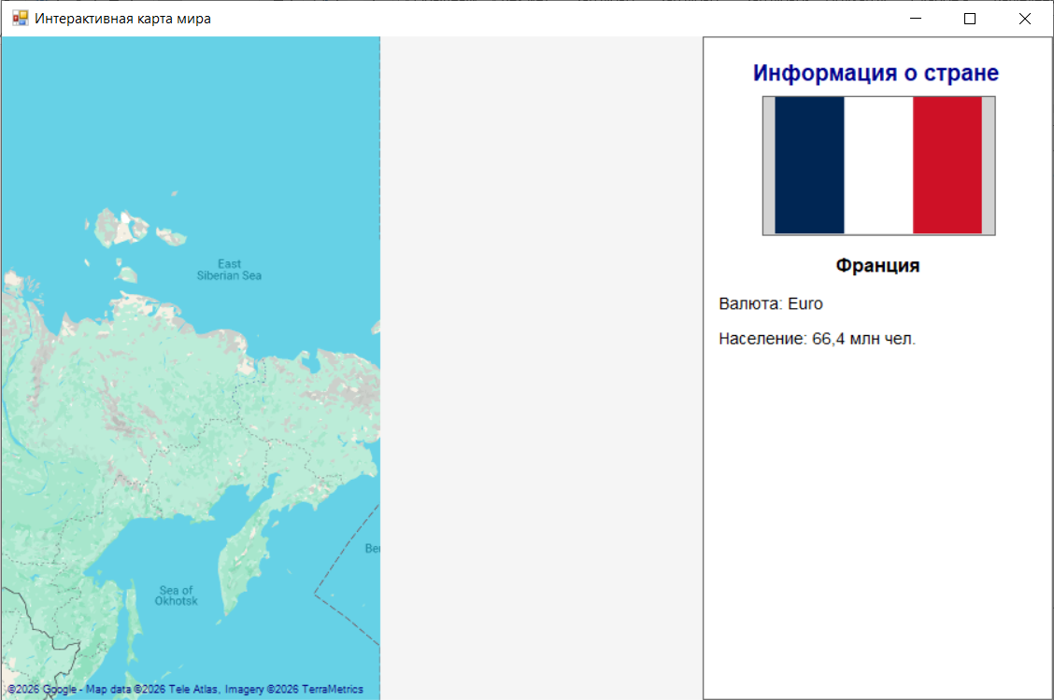
Нажимаем дважды или отключаем интернет:
